# 

# Indexing and Managing Documents in Elasticsearch

## 1. Introduction

An index is not much fun without any documents, so in this section, we will learn how to add or "index" documents into an Elasticsearch index. While 'indexing' is the correct term, both 'adding documents' and 'indexing' may be used interchangeably.

## 2. Indexing a Document

1. To index a document, we send a POST request to an endpoint structured as follows:

- /<index_name>/_doc

2. The document to be indexed must be provided in the request body as a JSON object.

3. Elasticsearch will store the entire JSON object as a document, and any valid JSON can be used.

4. **Example: Indexing a product document into the 'products' index**.

POST /products/_doc  
{  
 "name": "Sample Product",  
 "price": 99.99,  
 "in_stock": true  
}

5. **The response includes**: 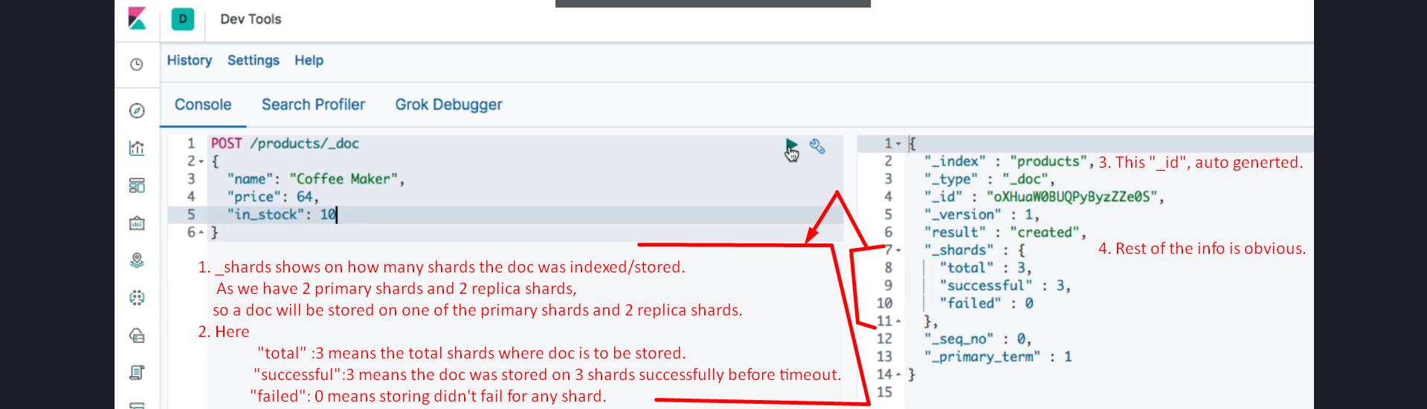

- **_shards**: Details how many shards succeeded or failed to store the document.

- Example: If the document is stored on one primary shard and two replica shards, the replication group consists of three shards.

- **_id**: A unique identifier for the document. If not specified, Elasticsearch generates it automatically.

## 3. Adding a Document with a Custom ID

1. To specify a custom ID for a document, the HTTP verb must be changed to 'PUT' (as per REST API conventions).

2. Append the desired ID to the endpoint.

3. Example: Adding a document with ID 100 to the 'products' index.

**PUT** /products/_doc/100  
{  
 "name": "Custom Product",  
 "price": 199.99,  
 "in_stock": false  
}

4. The response will confirm that the '_id' key contains the specified ID.

5. Note: The ID is treated as a string and does not have to be numeric.

## 4. Auto-Creation of Indices

1. Elasticsearch has a cluster-level setting, **'action.auto_create_index,'** that determines if indices should be created automatically.

2. Default value: **true**.

- If a document is added to a non-existent index, the index is automatically created before storing the document.

3. Best Practice: Explicitly create indices in production environments, but this feature is convenient during development.

## 5. Summary

1. Documents can be indexed using a POST request to the endpoint '<index_name>/_doc'.

2. Custom IDs can be assigned to documents by using a PUT request and appending the ID to the endpoint.

3. The '_shards' object in the response provides details about document storage across primary and replica shards.

4. The 'action.auto_create_index' setting allows indices to be created automatically, simplifying development workflows.